 | 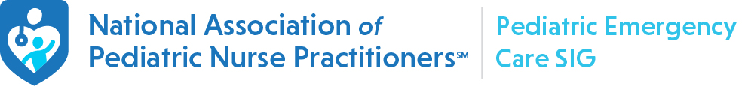  BEHAVIORAL HEALTH AND THE EMERGENCY CARE ENVIRONMENT:  A SPECIAL GUEST EDITION OF THE PEDIATRIC EMERGENCY CARE NEWSLETTER  ADAPTIVE SENSORY CARE IN THE EMERGENCY ENVIRONMENT  By Amanda Orme  INTERMOUNTAIN HEALTHCARE PRIMARY CHILDREN’S HOSPITAL  Sensory processing (SP) occurs in the central nervous system where sensory receptors manage the individual perception of stimuli and influence behavior. Sensory processing difficulty (SPD) is when the brain cannot adequately process sensory stimuli and leads to sensory overload (SO) which is expressed as difficulty managing behavior. Symptoms of SPD and SO are higher in children with a diagnosis of developmental disorders (DD) such as autism spectrum disorder, attention deficit-hyperactivity disorder, anxiety, Fragile X syndrome, Down syndrome, or cerebral palsy but are also seen in 16% of neuro-typically developing children.  When compared to typically developing children, those with diagnosed DD have more frequent emergency care (EC) visits, more care delays, longer waiting room times and lengths of stay, with higher parental stress. The EC environment is difficult for children with SPD because it is full of sensory stimuli with bright lights, loud sounds, crowds of people, and rigid care processes with limited flexibility. When a child is experiencing SO in the EC environment, families may not have the usual or necessary resources needed to deescalate the child’s behavior.  Adaptive care is a strategy to add communication support, alter the environment, and provide items for distraction to help children cope in healthcare situations, and reduces the risk for SO (Chun et al., 2016). The adaptive care plan (ACP) is a record to document an individualized care strategy and can be used like a checklist (Liddle et al., 2018). Adaptive care begins when a child arrives in EC. Signs and forms are used to guide the process.  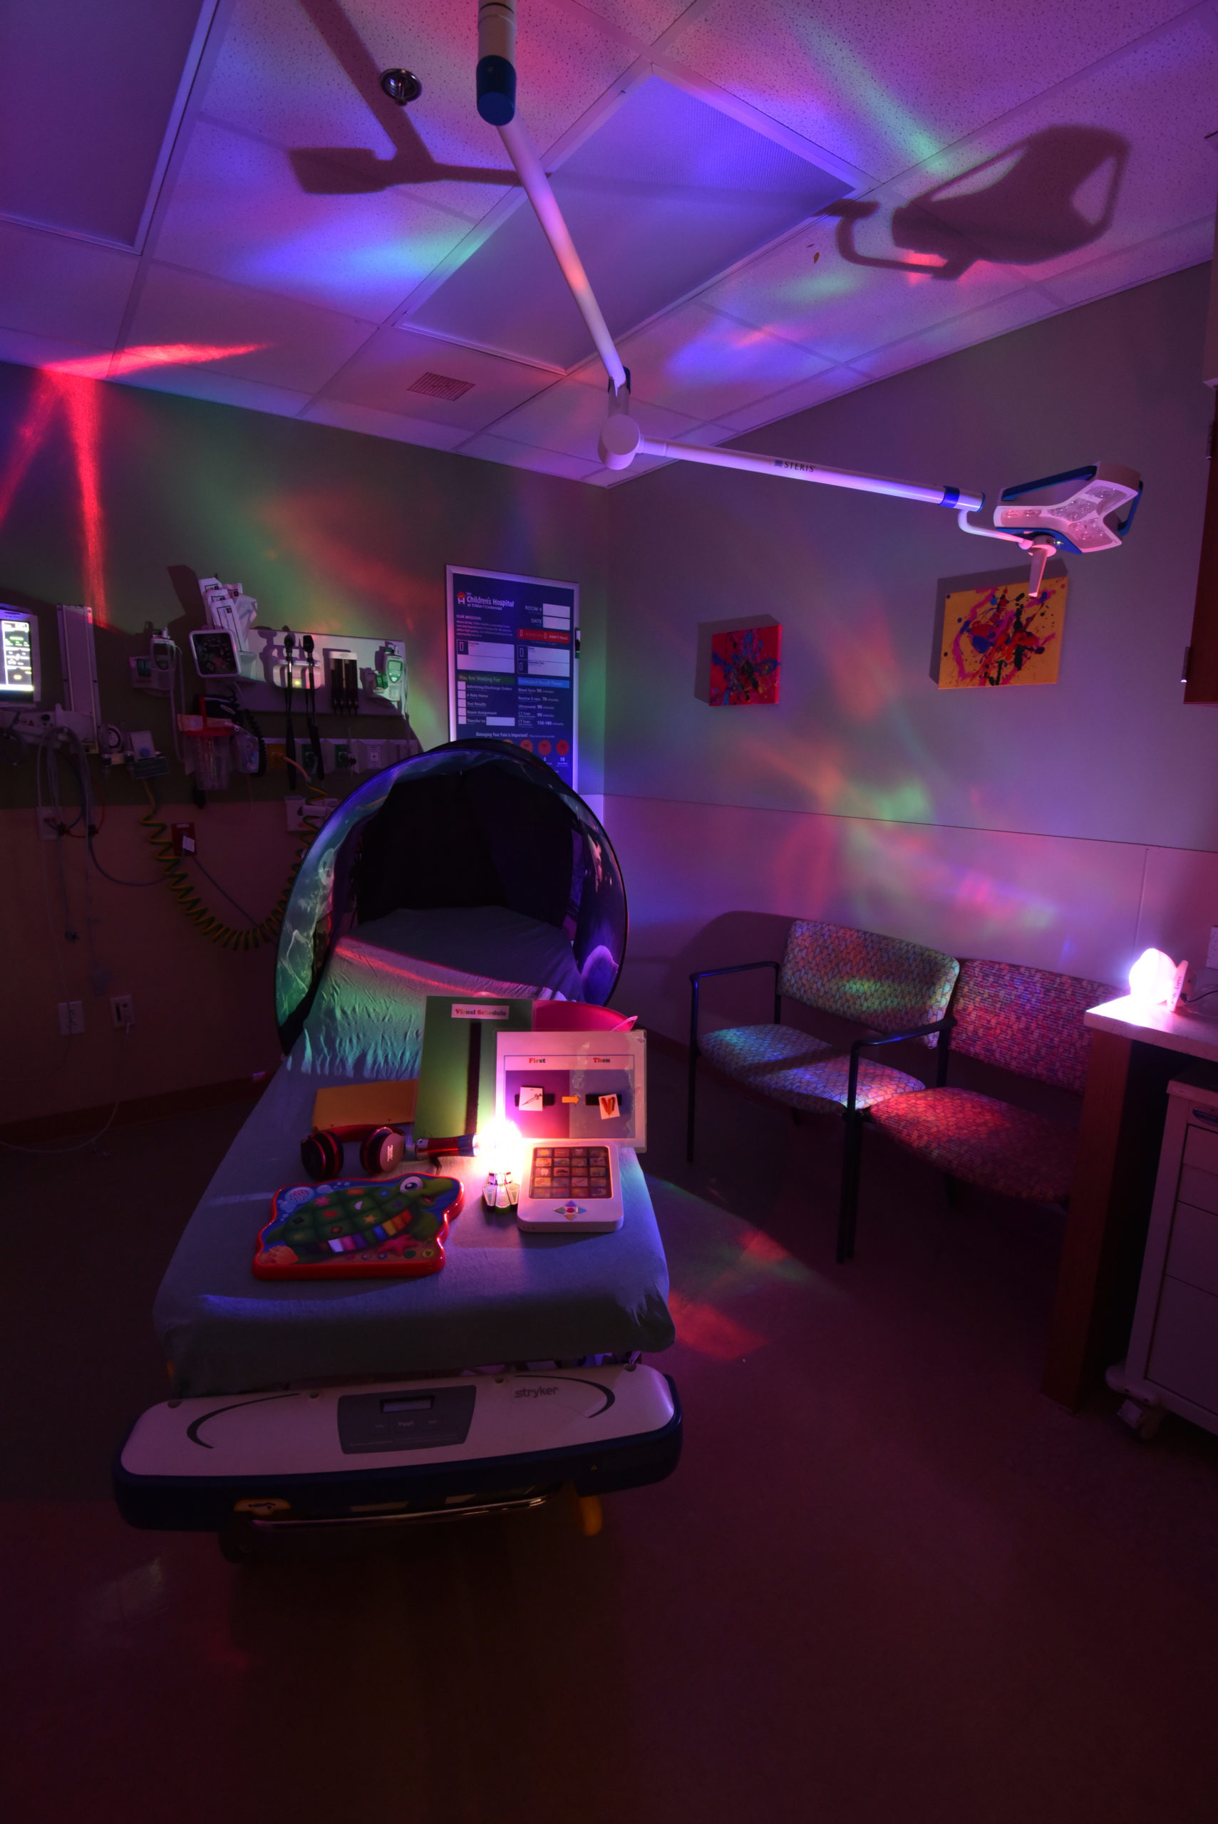  Modifications to usual care include using different communication techniques, modifying the environment, or offering distraction options. Children communicate using techniques they are used to and options to consider adding include word cards, social stories, or pictures that represent tasks done in a planned order (e.g., first/then, schedules), and procedural preparation. A few options to modify the environment include turning down lights, decreasing alarms when safety permits, and noise-canceling headphones. Options for distraction include fidget toys, iPad with sensory apps, a weighted vest/blanket, and working with a Child-Life Specialist.  Documentation of the ACP supports individualized care, shared decision-making, and improves communication between families and health care provider’s (HCP’s). The family are recognized experts on the needs of their child and help fill out the ACP. Storing the ACP in the medical record improves access to the information by all HCP’s; alternatively, if using a paper version, one page in length is best. It is feasible to create and implement an ACP in a busy tertiary ED aimed at reducing SO and improving the EC experience for children, their caregivers, and their HCP’s.  References  Chun, T.H., Mace, S.E., Katz, E.R., American Academy of Pediatrics  Committee on Pediatric Emergency Medicine, American College of  Emergency Physicians Pediatric Emergency Medicine Committee. (2016).  Evaluation and management of children with acute mental health or  behavioral problems. Part II: Recognition of clinically challenging mental  health related conditions presenting with medical or uncertain symptoms.  Pediatrics, 138(3), e20161573.  Liddle, M., Birkett, K., Bonjour, A., Risma, K. (2018). A collaborative approach to improving healthcare for children with developmental disabilities. Pediatrics, 142(6), e20181136
  March 11, 2022
  UPCOMING EVENTS
  - 43rd National Conference on Pediatric Health Care Dallas, Tx March 22-25, 2022
  - Next meeting of the Child Health Policy Learning Collaborative April 6th at 8pm EST. Email healthpolicy@napnap.org to be added to the monthly call.
  - Just in case you missed it, be sure to check out our special edition of the teampeds Talks podcast series, FocusED, available wherever you get your podcasts.
 | FocusED PODCAST WAS A HUGE SUCCESS!  This fall we were excited to introduce a special edition of the National Association of Pediatric Nurse Practitioner teampedsTalks podcast, FocusED, sponsored by the Pediatric Emergency Care Special Interest Group. FocusED is a podcast program created by the PEC SIG leadership that appeals to a broad range of listeners. By examining three different emergency care topics from a variety of different vantage points across the care continuum, FocusED highlights the many points of intersection between emergency care and the larger health care system.  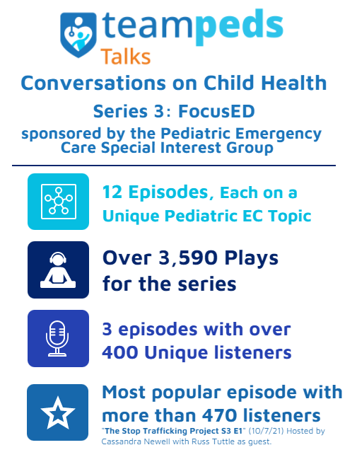  We hope you will take a listen to FocusED. Check out the teampedsTalks website for more information.  If you have an idea for a podcast and would be interested in recording an episode, please reach out to one of us. We would be happy to help get you started.  Let's keep this amazing momentum going!
    - Contact Us
  Pediatric Emergency Care
  Special Interest Group
  5 Hanover Square
  Suite 1401
  New York, NY 10004
  www.napnap.org/pec
  pediatricemergency@napnap.org
  Chair: Nicole Koepke, CRNP CPNP-PC
  Co-Chair: Hilary Baxter CRNP, PC/AC-BC
  Secretary: Cassandra Newell, CRNP, CPNP-PC

